Assignment Screenshots

**Question 1:**

Add Roles

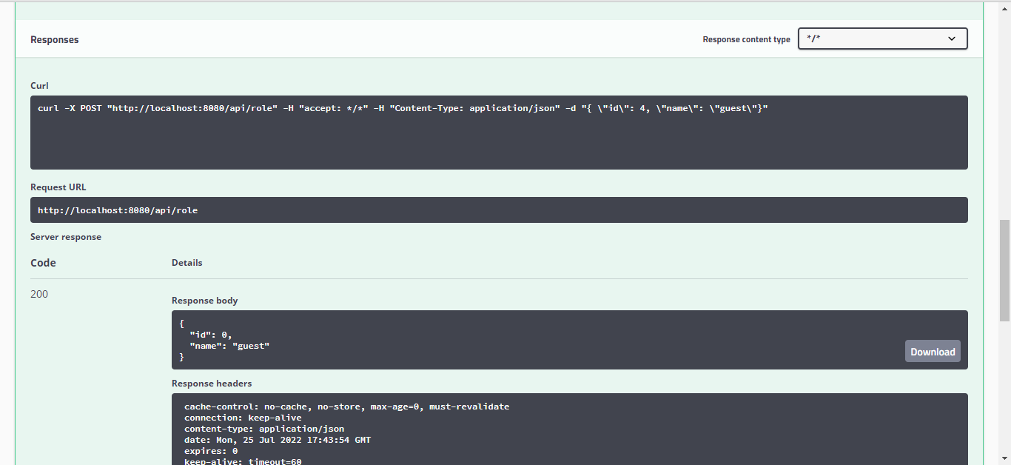

**Question 2:**

Add Users

**Question 3**

Add Employee

Logged in as Admin

Logged in as USER

**Question 4**

Get all Employees List

**Question 5**

Get employee based on Id

**Question 6**

Update employee.

**Question 7**

Delete an employee

**Question 8**

Fetch employees based on First name

**Question 9**

Sort Employees by firstName

